*NAME:* ***OKEMAKINDE SAMSON K.***

*MATRIC NUMBER:* ***170699***

*DEPARTMENT:* ***COMPUTER SCIENCE***

*COURSE:* ***CSC 231( SCIENTIFIC PROGRAMMING)***

*LECTURER:* ***DR AKINOLA***

***QUESTION:***

***A program that will accept scores for at least 20 courses and compute the cumulative grade point average for a particular student.***

***SOLUTION:***

***CODE:***

!A C.G.P.A calculator program implemented using files

!Written by OKEMAKINDE SAMSON: 170699: COMPUTER SCIENCE: 200LEVEL

!LECTURER: DR AKINOLA

!DATE: AUGUST 2014 @ UNIVERSITY OF IBADAN COMPUTER SCIENCE DEPARTMENT

!Data to be used must be entered in the format: coursecode score unit (separated by single tabs)

Program CGPA

Character(len=20)::name

Character*6::coursecode,remark,sex

Character*15::department

integer::matric,i,gp,unit,totalunit,wgp,totalfailedunit,totalpassedunit

Real::totalwgp,realscore,mycgpa

INTEGER error

OPEN(UNIT= 4, FILE='CGPAINPUT.DAT',STATUS='OLD',ACTION='READ',IOSTAT=error)

OPEN(UNIT= 5, FILE='TRANSCRIPT.DAT',STATUS='REPLACE',ACTION='WRITE',IOSTAT=error)

totalwgp=0

totalunit=0

realscore=0

totalfailedunit=0

totalpassedunit=0

wgp=0

gp=0

remark='PASSED'

Write(*,*)'Welcome to the CGPA Calculator'

Write(*,*)'What is your Name?: '

Read(*,*)name

Write(*,*)'What is your Matric Number?: '

Read(*,*)matric

Write(*,*)'What Department?: '

Read(*,*)department

Write(*,*)'Sex: '

Read(*,*)sex

Write(5,*)''

Write(5,*)'PROVISIONAL DEPARTMENTAL REPORT SHEET'

Write(5,*)department,' DEPARTMENT'

Write(5,*)'NAME: ',name

Write(5,*)'MATRIC NUMBER: ',matric

Write(5,*)'SEX: ',sex

Write(5,*)''

Write(5,*)'***********************************************************************************'

Write(5,*)'COURSE ','SCORE ',' UNITS',' GP',' WGP ',' REMARK'

Write(5,*)'***********************************************************************************'

Do i=1,20

Read(4,*)coursecode,realscore,unit

If (realscore<0)then

write(*,*)'Your score is invalid'

Else if(realscore>100)then

write(*,*)'Your score is invalid'

Else if(realscore<40)then

gp=0

totalfailedunit=totalfailedunit+unit

remark='FAILED'

Else if(realscore<45)then

gp=1

remark='PASSED'

Else if(realscore<50)then

gp=2

remark='PASSED'

Else if(realscore<55)then

gp=3

remark='PASSED'

Else if(realscore<60)then

gp=4

remark='PASSED'

Else if(realscore<65)then

gp=5

remark='PASSED'

Else if(realscore<70)then

gp=6

remark='PASSED'

Else

gp=7

remark='PASSED'

End if

! ending converting realscore to gp

wgp=gp*unit

totalwgp=totalwgp+wgp

totalunit=totalunit+unit

Write(5,7)coursecode,realscore,unit,gp,wgp,remark

7 FORMAT(A6,7X,F5.1,7X,I1,7X,I1,7X,I2,7X,A6)

End do

Write(5,*)'******************************************************************'

mycgpa=(totalwgp/totalunit)

totalpassedunit=totalunit-totalfailedunit

Write(5,*)'-------------------------------------------------------------------------------'

Write(5,14)totalunit,totalpassedunit

14 FORMAT('Total Units Taken=',I2,' ','Total Units Passed=',I2)

Write(5,2)totalwgp,mycgpa

2 Format('Total WGP= ',F5.1,' ','Cumulative Grade Point Average= ',F3.1)

Write(5,*)''

Write(5,*)''

Write(5,*)''

Write(5,*)'.....................................'

Write(5,*)'Head Of Department'

Write(5,*)'Any alteration renders this document invalid.'

Write(*,*)i,' records processed. Check file Transcript.dat for the result'

Write(*,*)' Thanks for using the program'

CLOSE(Unit=4)

CLOSE(Unit=5)

STOP

End program

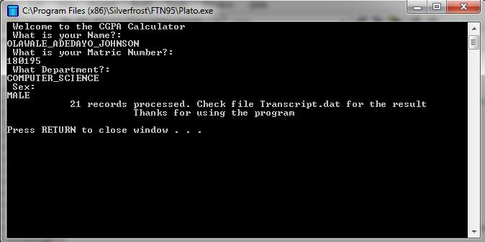**SAMPLE INPUT AND OUTPUT**

